Using the Check Your Knowledge quizzes – the things that have puzzled students.

- Decide all of your answers using the Preview link. You can either:
  - Jot them down on a piece of notebook paper
  - Print out the Preview link and use it to log all of the information you find as you take the quizzes and read in the textbook what you missed.
- Click on a Check Your Knowledge quiz.
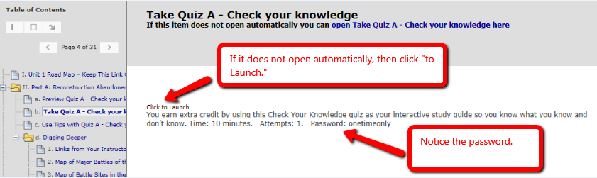

- Click Begin and enter the password. Notice no spaces between the words.

- Enter exactly what you planned when you listed your answers on that piece of paper or on that print of the Preview link.

- When you first take the quiz, you press the OK button to see which ones you missed and got right.
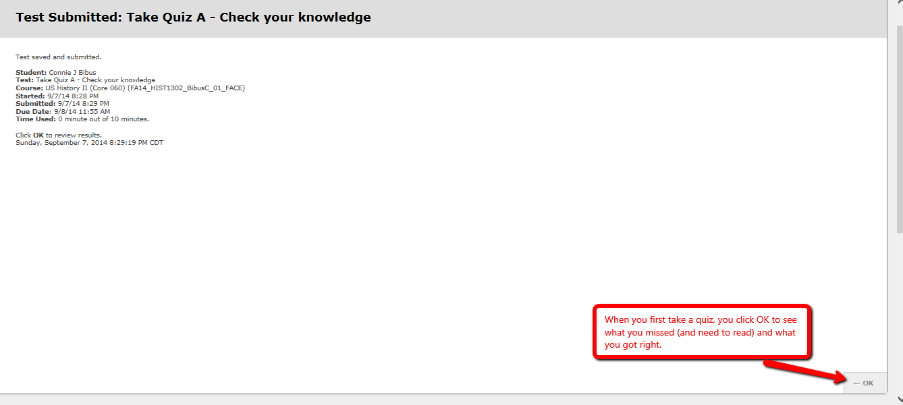

- If you decided you need to check on something and go back to see your completed quiz, you eventually see this screen.

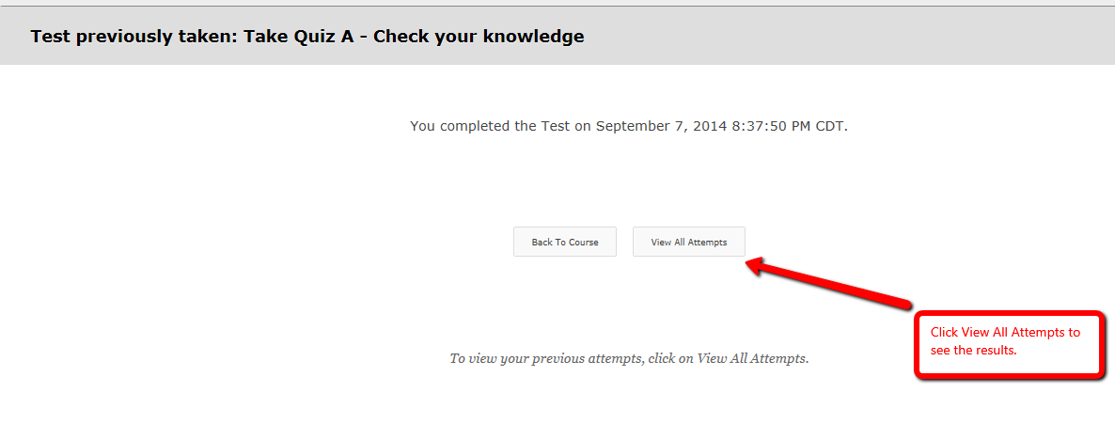
- Clicking on View All Attempts results in this screen. The red arrow shows what you click.
