STEPS_5_&_6: Two Quick Solutions for More Difficult IDs:
Solution for Problems with IDs That Are Longer Than Wide for THIS CLASS 1
Solutions for Taking Your Picture and Showing Your Photo ID—The trick is in the fingertips. 1

Solution for Problems with IDs That Are Longer Than Wide for THIS CLASS
If you have—for example—a Texas license that is longer than wide, place your license close to the webcam with only two things clearly visible:
- Your name
- Your photo
In other words, in THIS class, you do not need to show the decorative areas at the top and the bottom.

Solutions for Taking Your Picture and Showing Your Photo ID—The trick is in the fingertips.
Error! Reference source not found.To make sure students do not have another person take their tests, profs are required to compare these 2 things to determine:
- If the photo of the person taking the test is the person in the picture on the PHOTO ID.
- If the name on the PHOTO ID matches the name you used in registering for the class (with that name visible to profs in Respondus).

Here is the method that a smart student from a prior class used.
 |  |  | ↓ ↓ ↓ (Fingertips)
 | 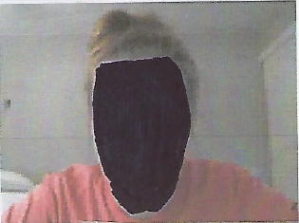 |  | 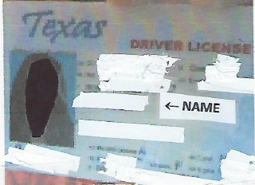
 | Student Photo |  | Student ID ↑ (Thumbtip)

To make the profs’ jobs possible, WCJC requires:
- Students take a picture of themselves within Respondus. Caution: Notice her face (and yours) must “fill the frame.” Your face must be big enough the prof can see it, and there is NOTHING of your body in that picture.
- Students place their Student ID next to the webcam and take a picture. Notice the position of the fingertips and thumbtip that let you put your hand closer to the webcam.
Caution: You will lose 30% if you rotate your PHOTO ID to make it fit. Reminder: Profs must compare your Photo ID with your name in Blackboard and with the picture you take of yourself to confirm to the college that you are the correct person. No prof could afford the time to do something like make a snippet to rotate the picture for the comparison.

