Hi,
This will be a link in the Discussion where Ms. Pritchard asked her excellent questions and it will also be a link in the email to you all in Blackboard Course Messages.
- First things, I am so sorry that I blew it and that your class became a user test for Fact-Checking. I cannot undo the lost time and frustration, but I have made these attempts to show my regret:
- A grade APOLOGY EVIDENCE DRAFT-1 – It has 25 extra credit points already entered.
- A grade APOLOGY EVIDENCE DRAFT-2 – If you do Part 2: Fact-Checking, I will enter another 25 extra credit points.
- And if the 2nd extra credit helps some or all of you persist, I have no problem doing a 3rd. I am really sorry.
- Right now you can see the feedback on your Evidence Draft.
  - Click on My Grades.
  - Scroll down to Part 1: Evidence Draft
  - Click on the
Blackboard then displays what I wrote to you. Tip: It may be similar to this one because this one has comments to 3 or 4 students mixed together.
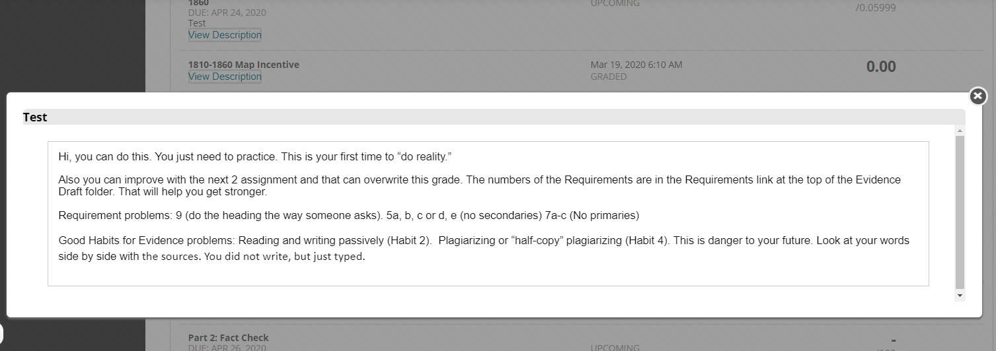
- Look at the example above. You are expected to do these same things for the other student:
- Requirements problems. Those are followed by numbers from the Requirements link in the folder.
- Good Habits for Evidence problems. Those have a number, either Habit 1, 2, 3, 4, and 5.
- The Fact-Checking folder is immediately below the Evidence Draft folder. Tip: Evidence Draft is now Read Only.
- Caution: Do not click on Discussions to do this work.
- The Fact-Checking folder will open Sunday at 8:00 AM.
- At the top of the folder, the instructions for 100 points for fact-checking 1 paper
  - What you need to cover about Requirements
  - What you need to cover about Good Habits for Evidence
  - How you enter your feedback so it is readable to everyone
- Aid to help you with the Requirements
- Aid to help you with the Good Habits for Evidence
- The Fact-Checking discussion with your papers exactly as they were in Evidence Draft
After I am sure you guys are OK, I will update your List of Due Dates for when Part 2: Fact-Checking is due and when Part 3: Final Evidence Paper is due.
Again, I am so sorry,
Dr. B

