Hi,
- First things, I am so sorry that your papers took so long. There is extra credit as an apology. See the grade– It has 25 extra credit points already entered. If you persist with Part 2 (and Part 3), there will be 25 more each time.

- Second, some of you did great and some of you did not.
  - If you did great or very good, your points are fine. Some of you were not as great as you would have been if we had been together in a room where your natural ability to ask questions would have helped us all, but you were still very good. Here is a highly optional link to some of the things that might have come up in class that I have suggested to some of you. The link might clear up things before you do the Fact Checking. You can decide if it might help you by clicking here and looking at the little table of contents at the top. Link Address: http://www.cjbibus.com/Questions_And_Answers_That_Might_Help_You_1302_3_Part_Writing.pdf
  - If you did not do as well as you can, you can overwrite your Evidence Paper grade by taking seriously the requirements of Fact-Checking for 2 other students. Do read all of the instructions carefully before you start clicking.
What does overwrite mean? That is explained in the email sent 4/30.
  - If you have a 1.11 for your Evidence Paper, you can also overwrite that grade
    - by doing correctly what is required for Fact-Checking
    - and not doing what you did on the Evidence Paper.
To overwrite the Evidence Paper grade, you must do both i. and ii. Ask by email if you have questions.
- Right now you can see the feedback on your Evidence Paper.
  - Click on My Grades.
  - Scroll down to Part 1: Evidence Paper
  - Click on the
Blackboard then displays what I wrote to you. Although the way to get to your feedback is the same, your papers have very long feedback. I am trying to help students based on what I was seeing.
You will not be doing long feedback. You will focus only on making your comments about Requirements problems and Good Habits for Evidence problems
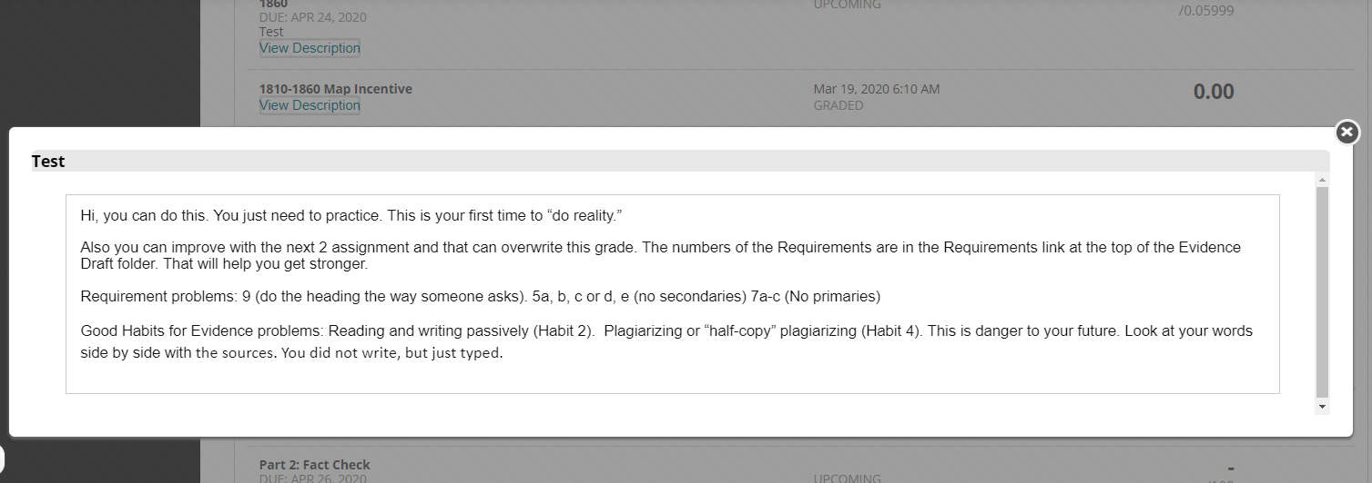
- You are expected to do these same things for the students you are Fact-Checking, but you will place the comment immediately below the problem by inserting a comment as shown in the instructions
- Requirements problems. Those have a number, the same numbers in the Requirements link you were to use when you wrote your paper. Tip: There is a Checklist to help you and you can copy and paste from that into your comments to the person you are fact-checking.
- Content problems and Good Habits for Evidence problems. Those have a number, either Habit 1, 2, 3, 4, and 5. If you do not remember the number, then just use the words in the rubric for that Habit.
- The Fact-Checking folder is immediately below the Evidence Draft folder. Tip: Evidence Draft discussion is now Read Only.
- Caution: Do not click on Discussions to do this work. Work in the folder where you can see the instructions.
- The Fact-Checking folder will open 5/1 at 8:00 AM.
- At the top of the folder, a link with requirements, tips, and how to do your comments for the 100 points for fact-checking 1 paper
  - What you need to cover about Requirements
  - What you need to cover about Good Habits for Evidence
  - How you enter your feedback so it is readable to everyone
- Aid to help you with the Requirements
- Aid to help you with the Good Habits for Evidence
- The Fact-Checking discussion with your papers exactly as they were in Evidence Draft – but
After I am sure you guys are OK, I will update your List of Due Dates to show Part 2: Fact-Checking is 5/7 at 11:59 PM.
Again, I am so sorry for the delay.
Dr. B

